EXPERIMENT 6
Ex. No.: 6
Design of a Quarter-Wave Transformer for Impedance Matching
AIM: To design a quarter-wave transformer for matching a load to a source and to find its impedance and length using Scilab.
SOFTWARE REQUIRED: Scilab 6.1.1
PROGRAM
clear; clc;
ZL=100; ZS=50; f=500e6; c=3e8;
Zt=sqrt(ZS*ZL); lambda=c/f; length=lambda/4;
printf("Quarter-wave transformer impedance = %.4f ohms\n",Zt);
printf("Wavelength = %.4f m\n",lambda);
printf("Transformer length = %.4f m\n",length);
TEST CASES AND OUTPUT
Test Case 1: ZS=50 Ω, ZL=100 Ω, f=500 MHz
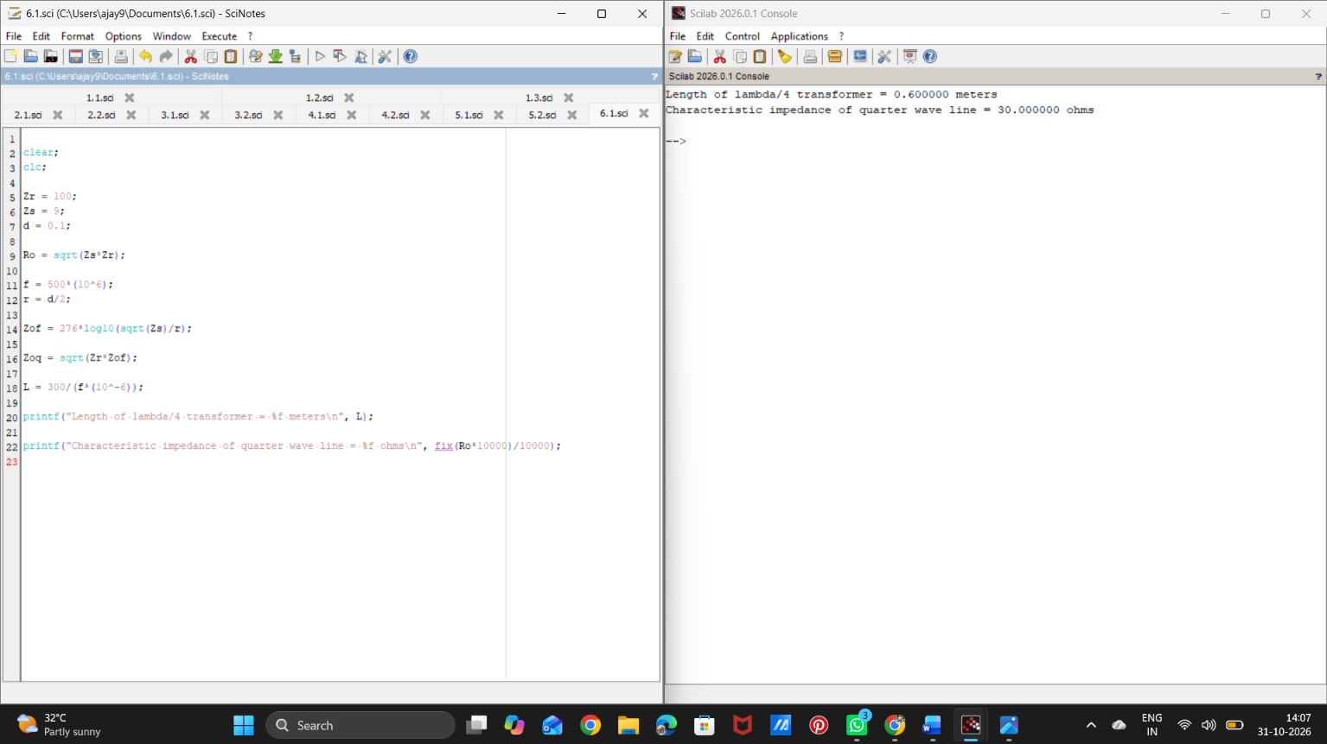

Test Case 2: ZS=50 Ω, ZL=75 Ω, f=1 GHz
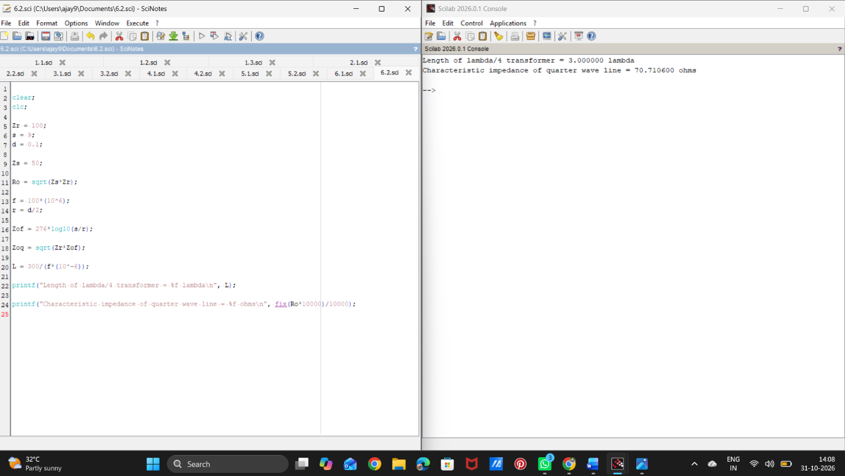

RESULT
Thus, the quarter-wave transformer was designed and its impedance and length were calculated using Scilab.

